
WEATHER TUESDAY 7th APRIL 2026
VALID 0630-1000
Situation: A SW’ly air stream will develop across the state as a weak cold front continues to move eastwards. Showers with the front will clear by mid-morning.
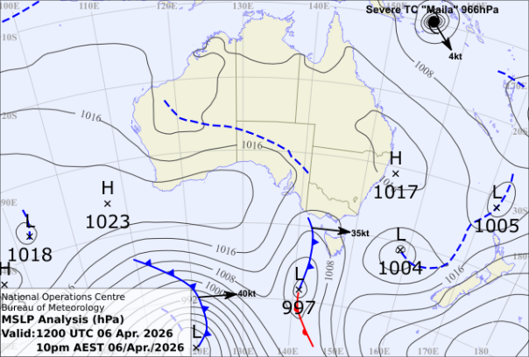
SURFACE WIND: 100/03kts.
WEATHER: Showers clearing.
CLOUD: BKN 500ft showers. SCT 3000FT BKN ABV 5000ft
VISIBILITY: 5000m showers otherwise
unrestricted
TURB: MOD near showers.
TEMP: 12c rising to 19c by 1000.
Max 25c.
AREA QNH: 1012
SUNRISE: 0634.
Remarks: Patchy fog/low cloud possible.
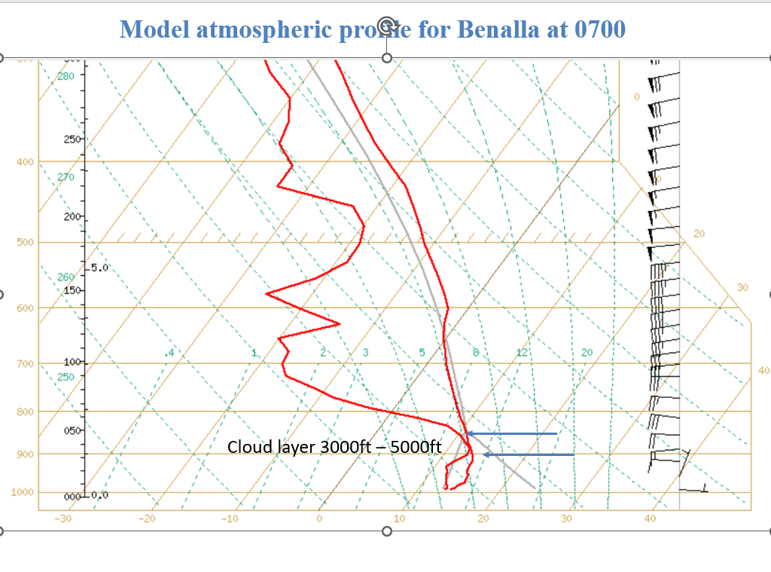

FORECAST WINDS AGL (kts/true)
10000 | 260/30
7000 | 270/28
5000 | 270/26
4500 | 270/24
4000 | 270/20
3500 | 270/18
3000 | 260/17
2500 | 270/14
2000 | 280/12
1500 | 300/09
1000 | 010/06
750 | 050/06
500 | 080/06
300 | 090/05
100 | 100/03

WINDSONDE 0400 AGL (kts/true)
